CCIQ Business Wellness Program - Guidelines for Media Release

Your logo
Release date
Headline (name of your mental health initiative)
Copy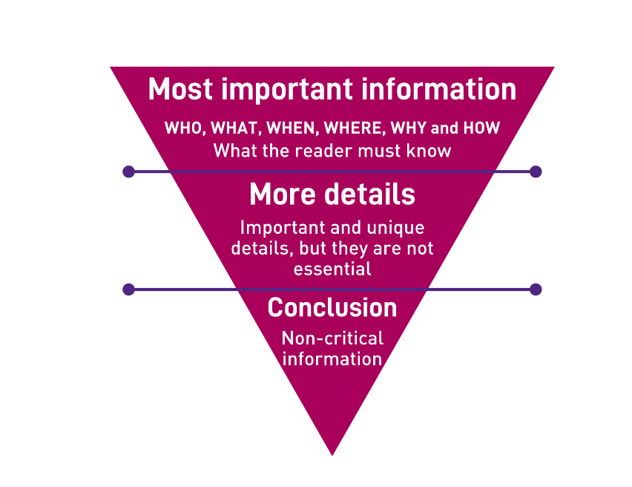
Key facts:

Editors note:
ENDS
Media contact:
[Name]
[Position]
[Email] | [phone]

